Estrella Aguilera Moreno

Esagmo96@gmail.com

Performance report

Acme-Santiago v1.0

**Introduction**

In order to evaluate the performance of the project, we split the functional requirements into use cases and developed one JMeter test per use case. 150 concurrent users were used in all tests except the 3.1, 3.2, 3.3, 3.4, 4.1.1, 4.1.2, 4.1.3 and 15.1 in where it was used 200. When it was increased above that we got random “Connection closed by peer” type errors in JMeter, at a very low probability, which increased if we increased the number of concurrent users more. Since at 150 users the system was always stable with 0.00% errors, we decided that the system supports a maximum of 150 simultaneous users.

**3.1 – Register as a user.**

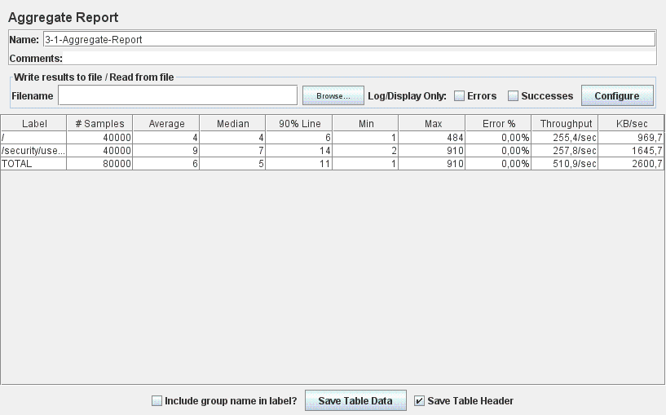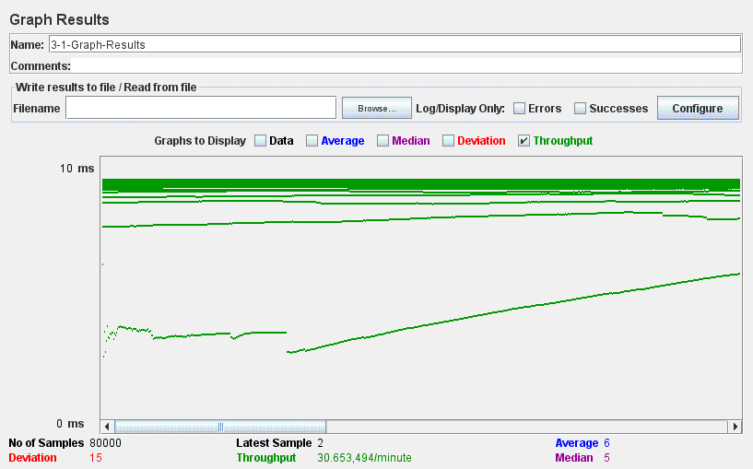

**3.2 – Browse the routes.**

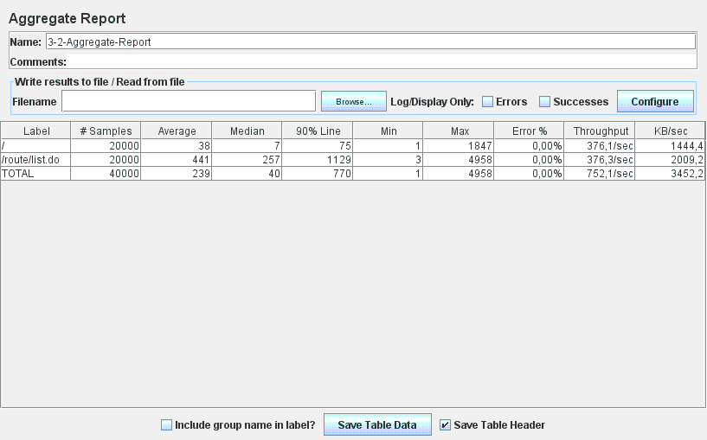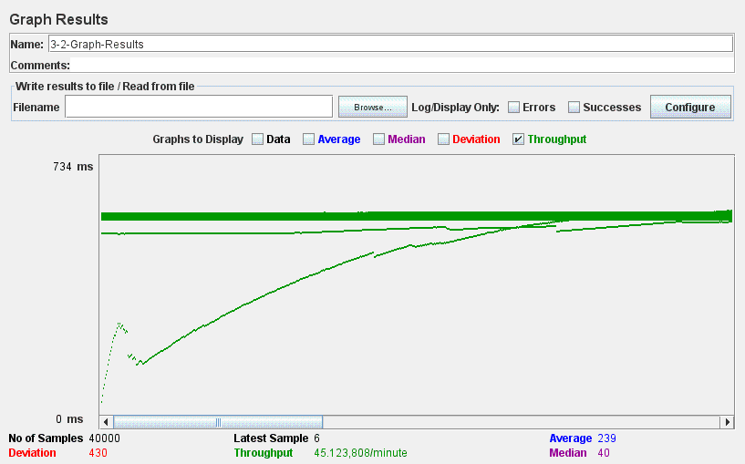

**3.3 – Search for routes using a single key word.**

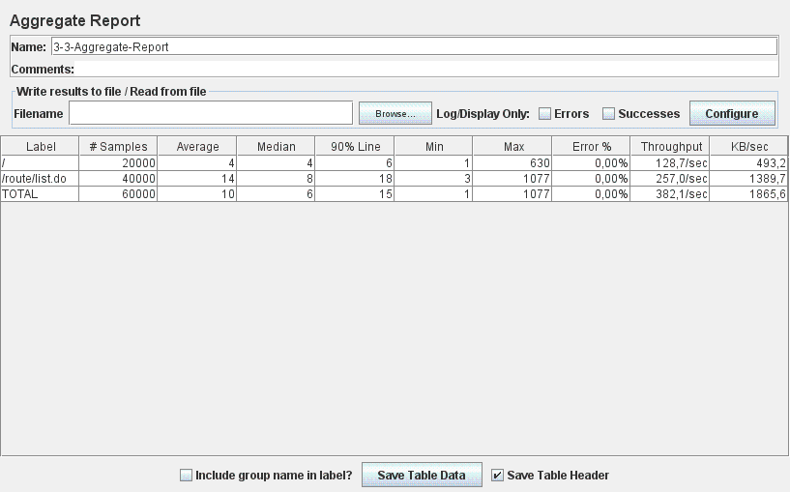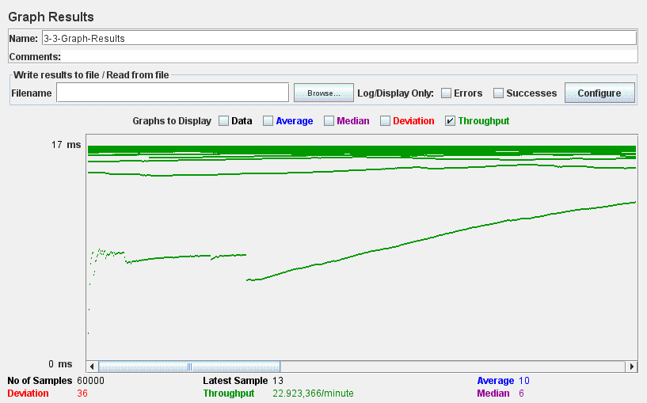

**3.4 – Search for routes whose length is in a user-provided range.**

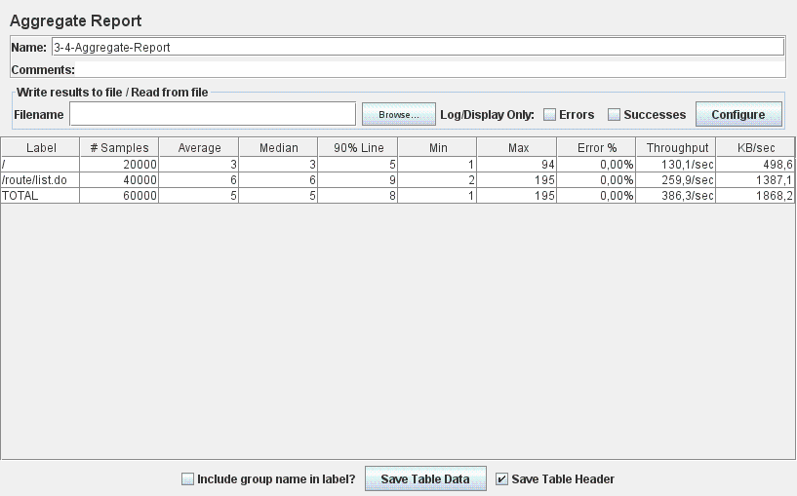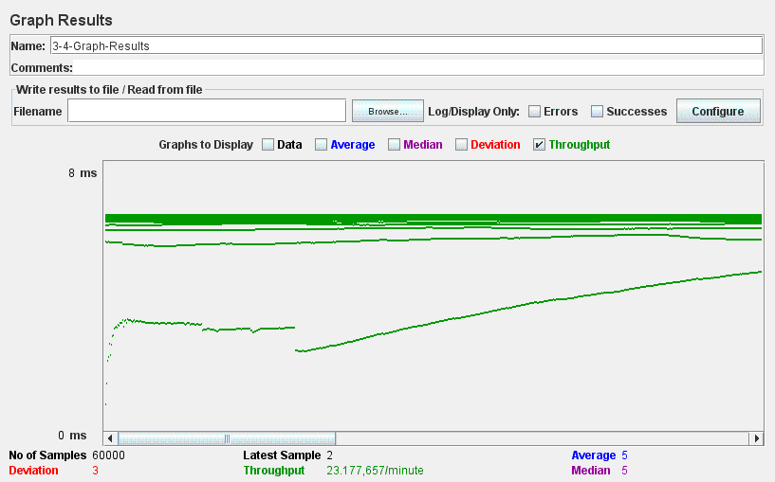

**3.5 – Search for routes that have a minimum or a maximum number of hikes.**

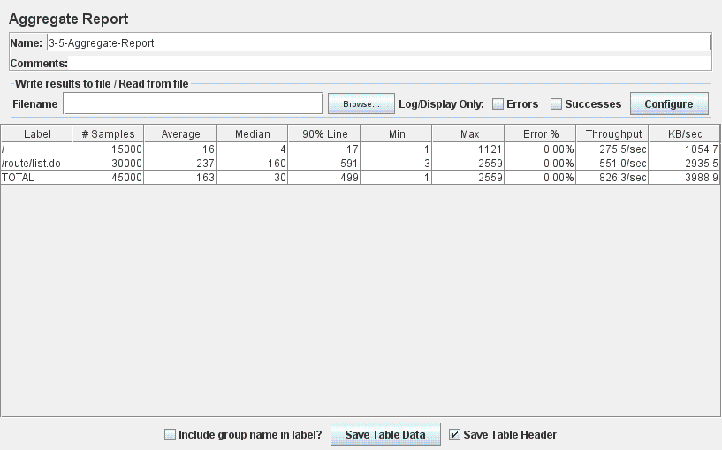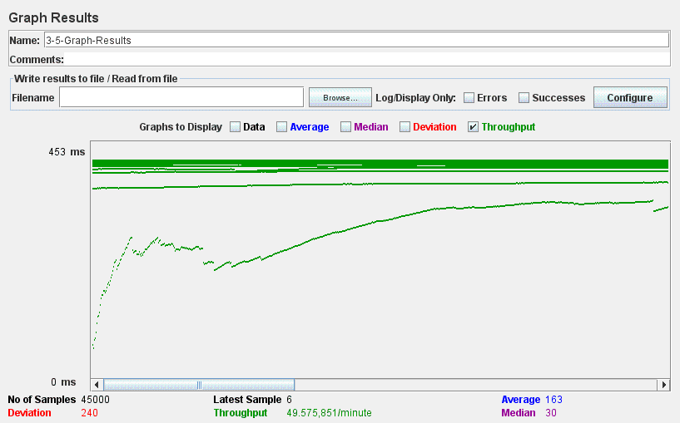

**3.6 – Browse the user of the system and their profiles.**

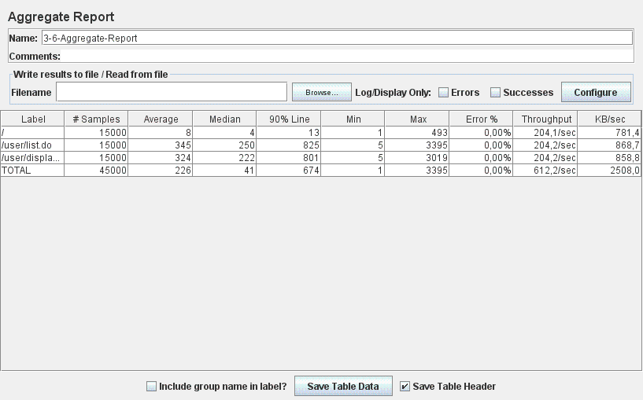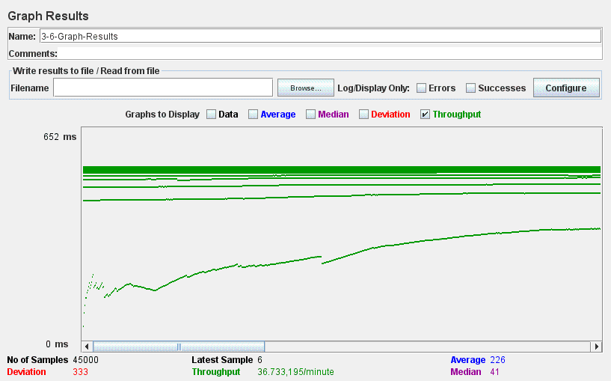

**4.1.1 – Browse the routes being authenticated.**

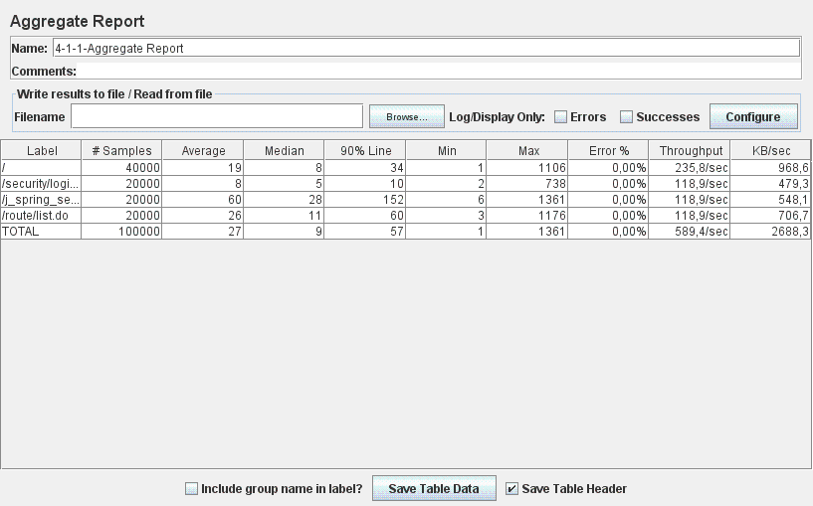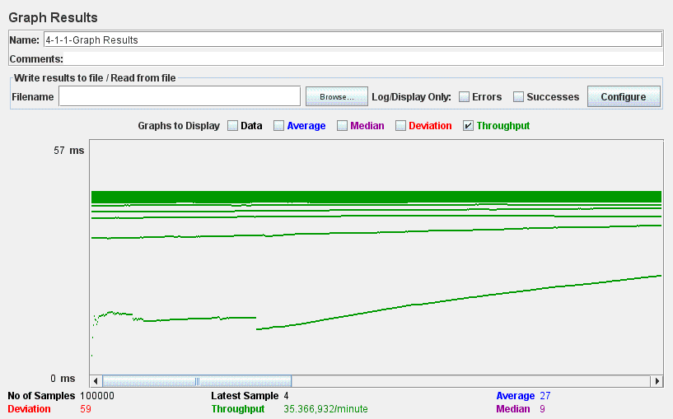

**4.1.2 – Search for routes using a single key word being authenticated.**

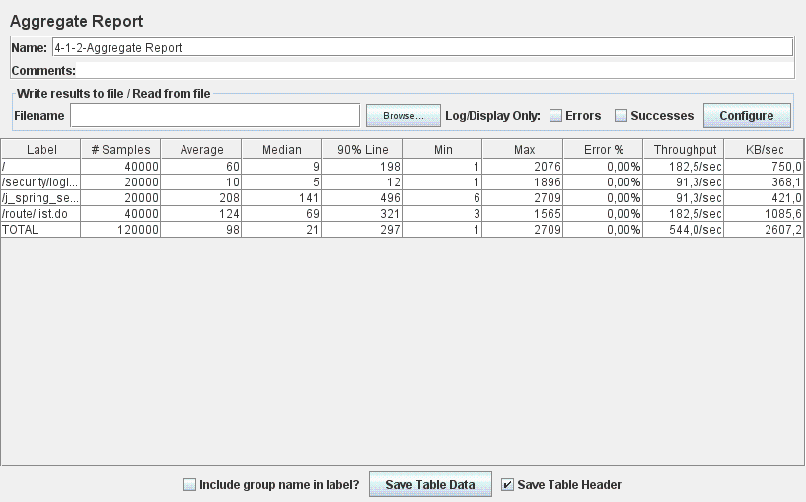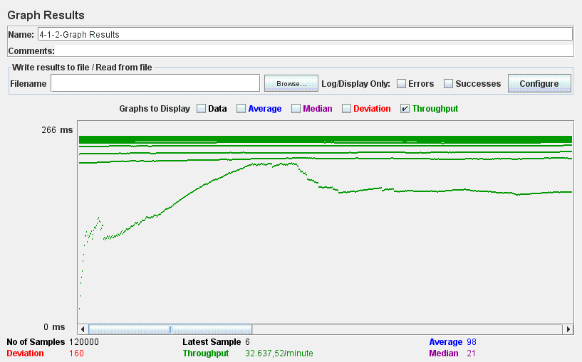

**4.1.3 – Search for routes whose length is in a user-provided range being authenticated.**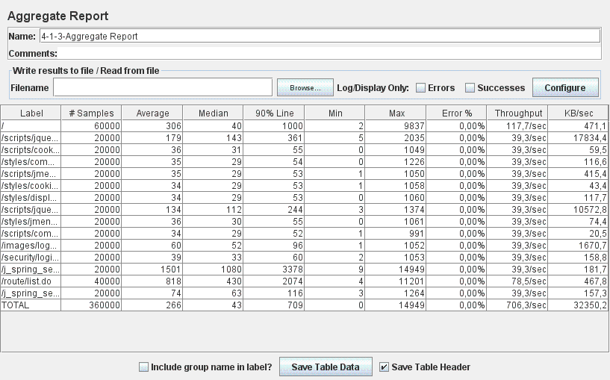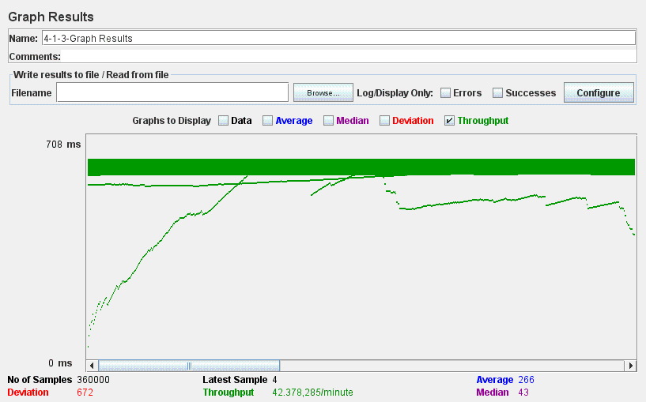

**4.1.4 – Search for routes that have a minimum or a maximum number of hikes being authenticated.**

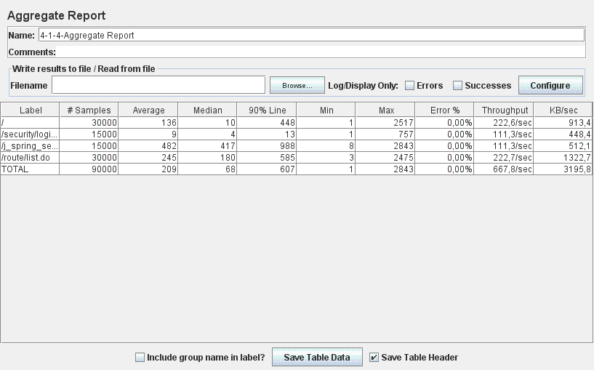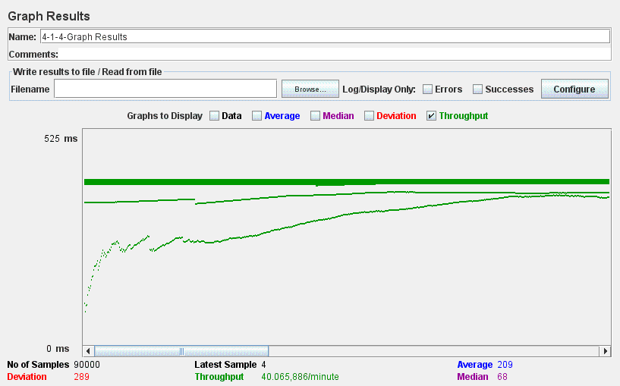

**4.1.5 – Browse the users of the system and their profiles being authenticated.**

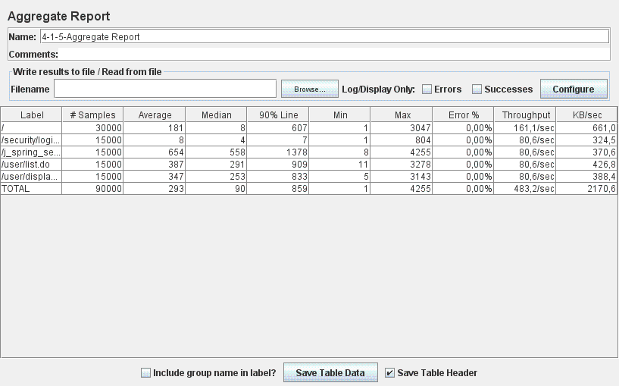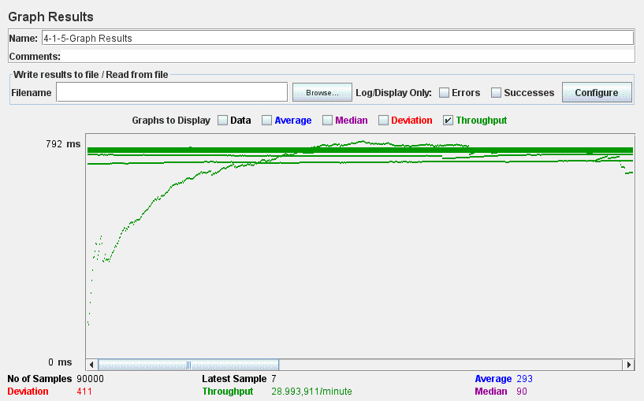

**5.1.1 – Create a route being a user.**

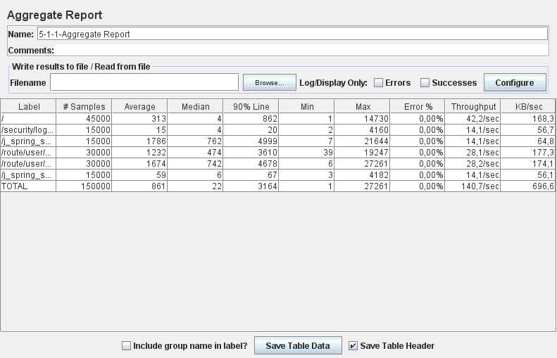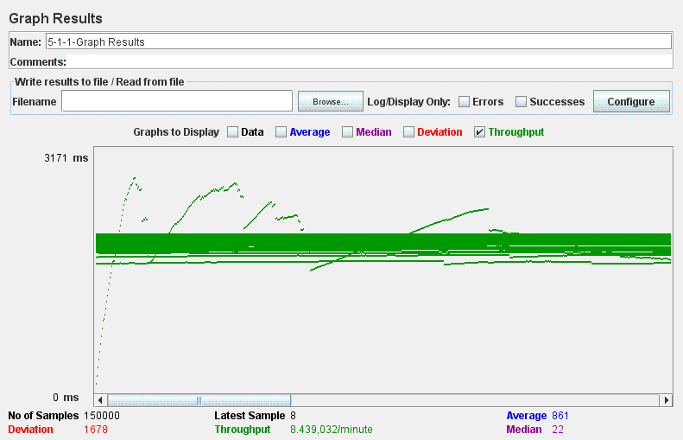

**5.1.2 – Edit a route being a user.** 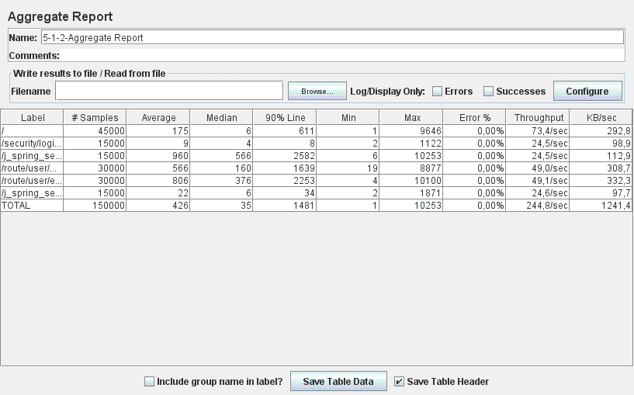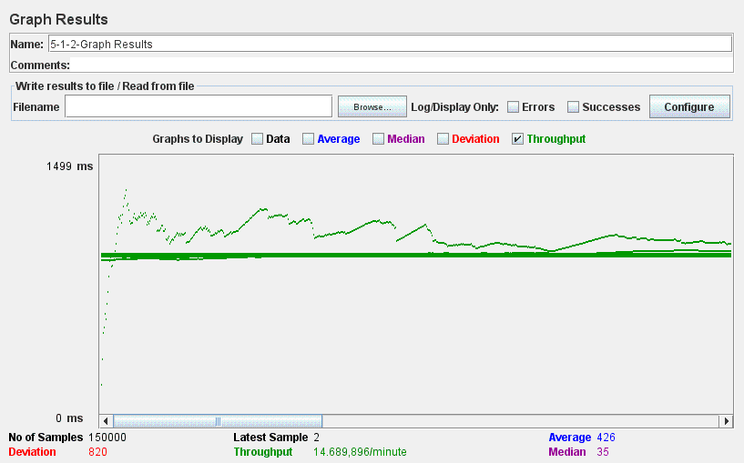

**5.1.3 – Delete a route being a user.**

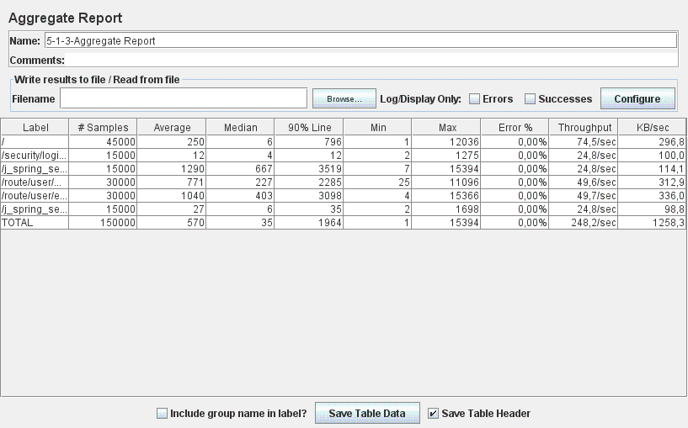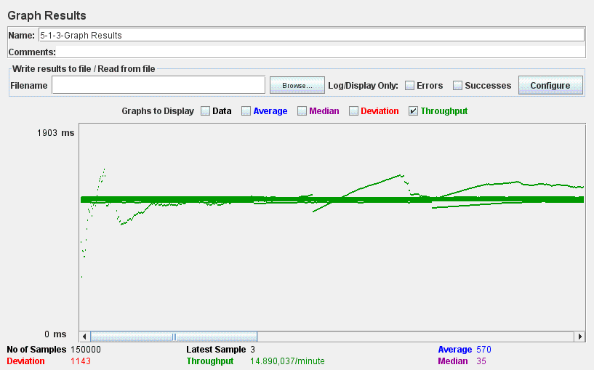

**5.1.4 – List the routes being a user.**

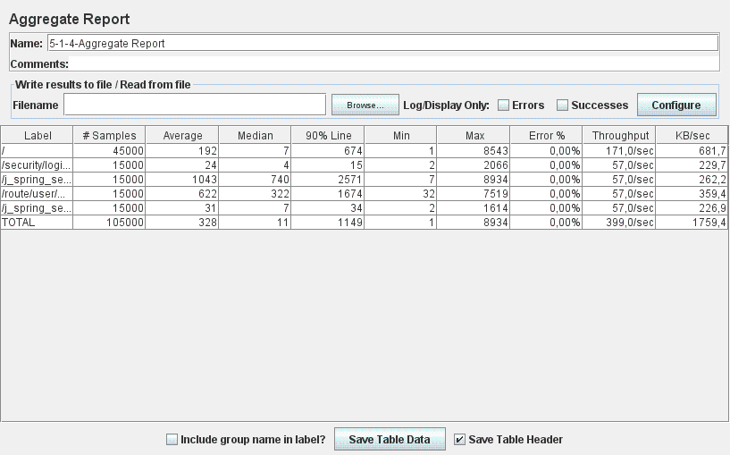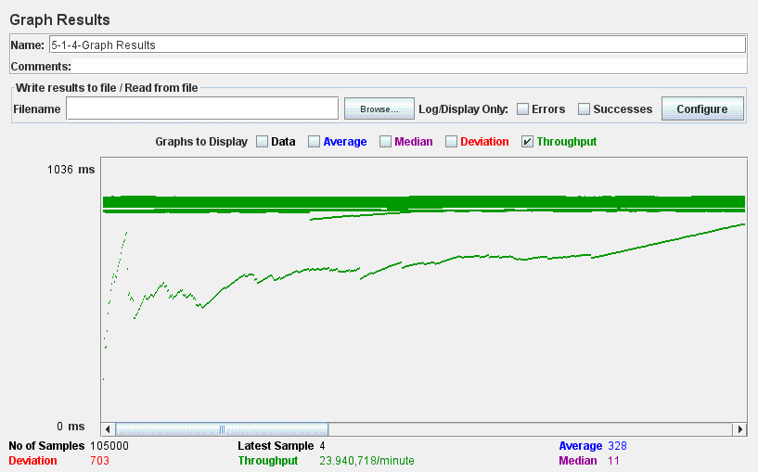

**5.2 – Follow/unfollow other users being a user.**

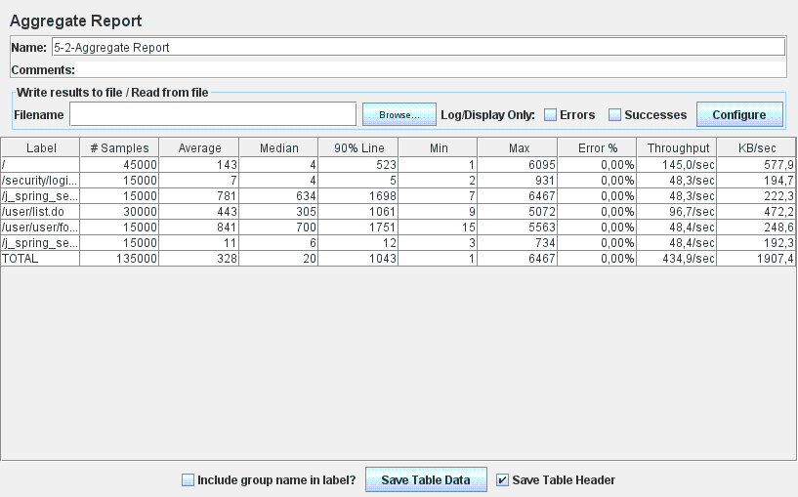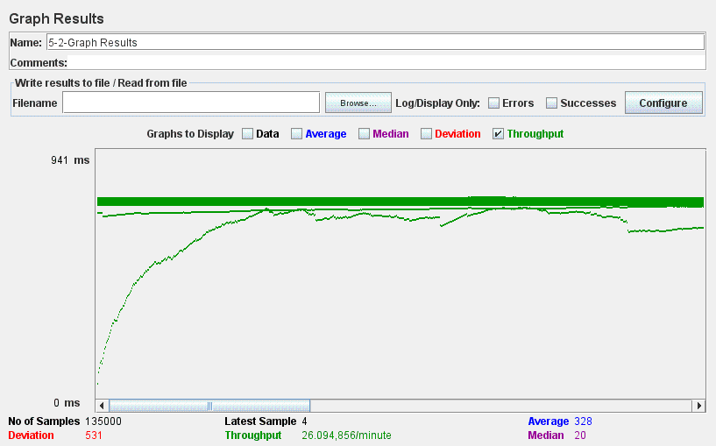

**5.3 – Browse the user who he or she follows being a user.**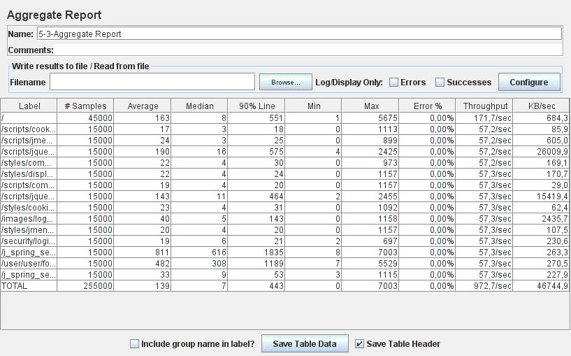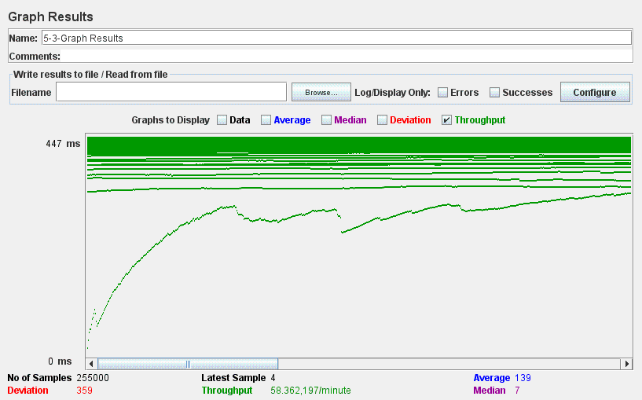

**5.4 – Browse the users who follow him or her being a user.**

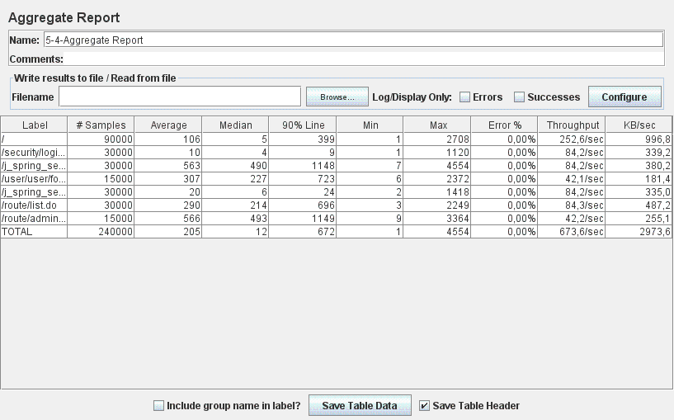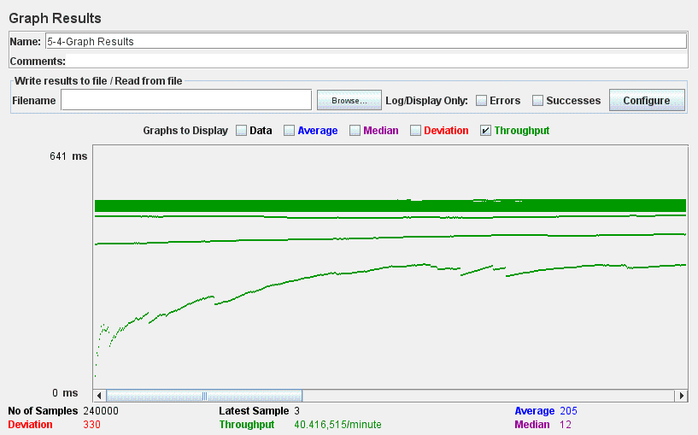

**6.1 – Remove a route being an administrator.**

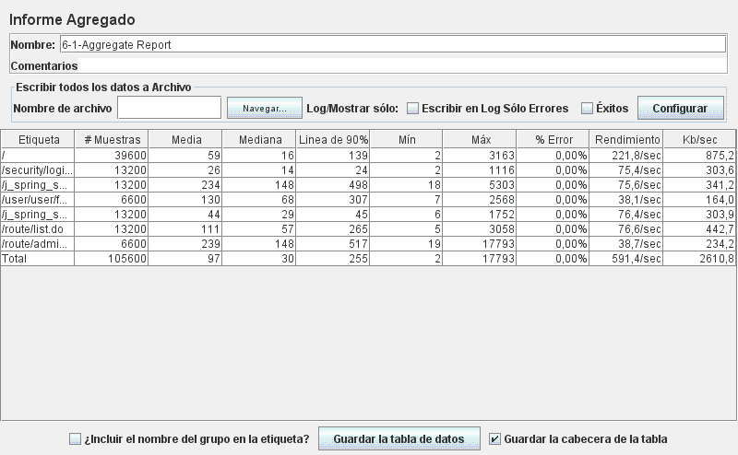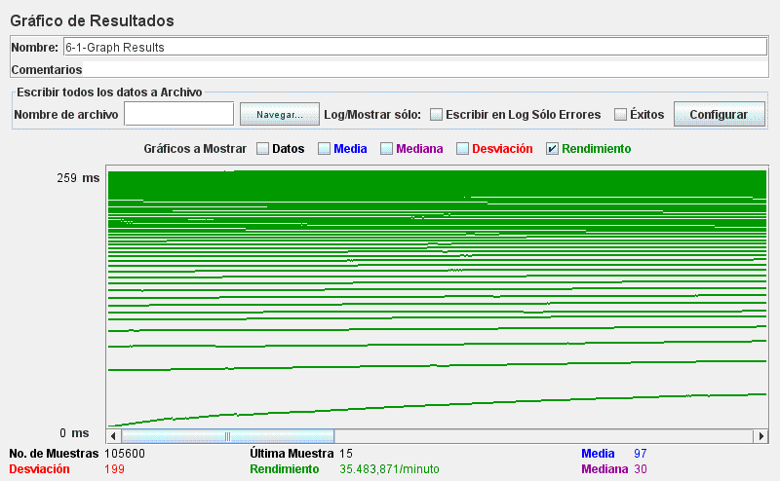

**6.2 – Display a dashboard being an administrator.**

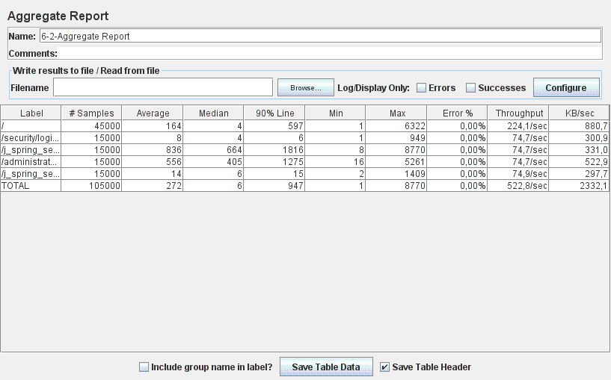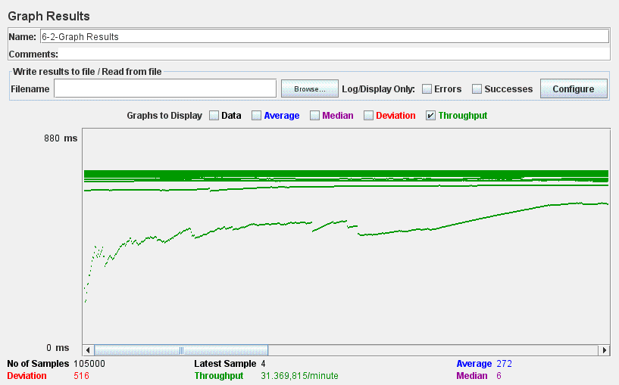

**15.1 – Post a chirp being a user.**

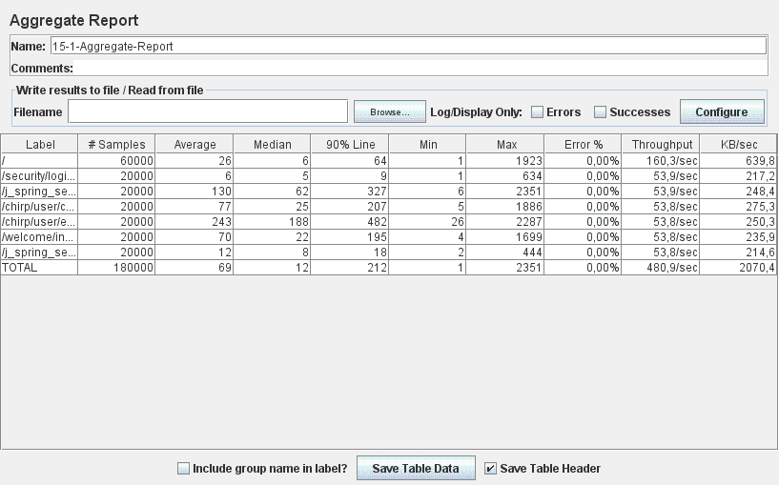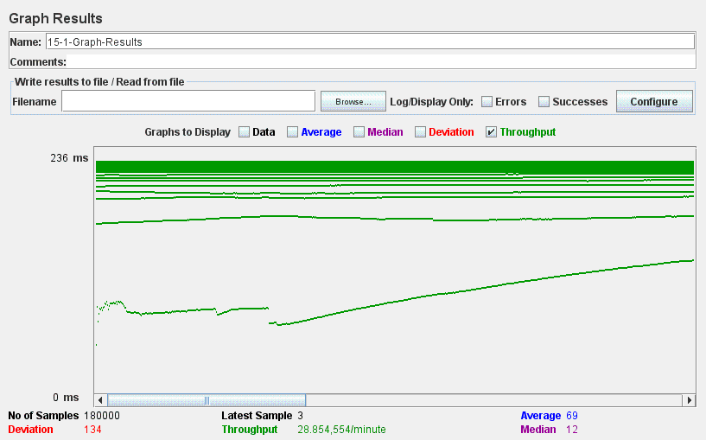

**15.2 – Display a stream with the chirps posted by all of the users that he or she follows being a user.**

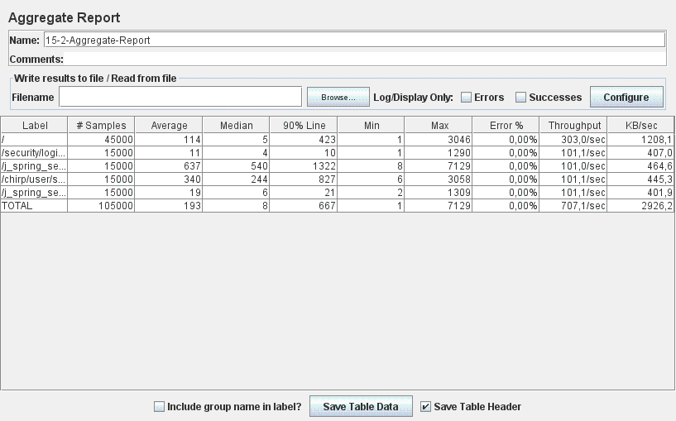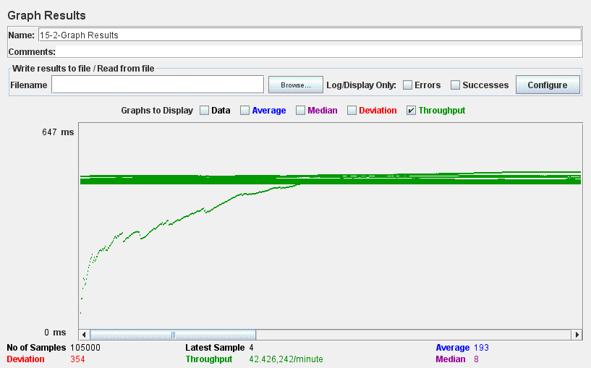

**16.1 – Manage a list of taboo words being an administrator.**

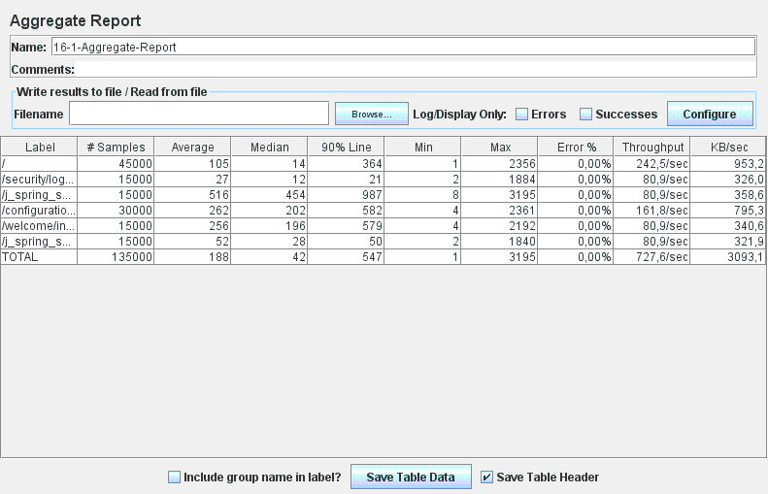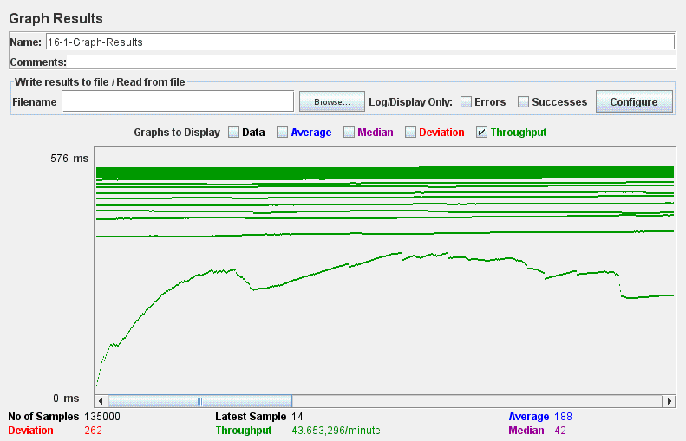

**16.2 – List the chirps that contain taboo words being an administrator.**

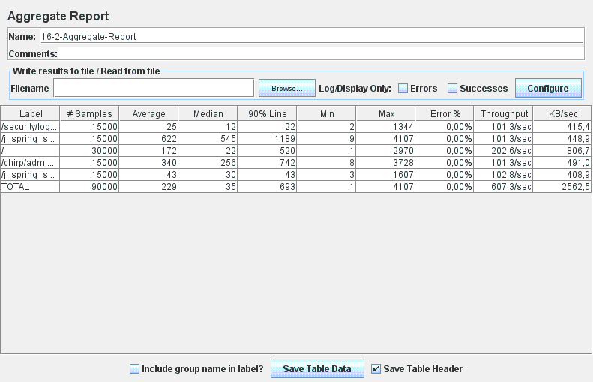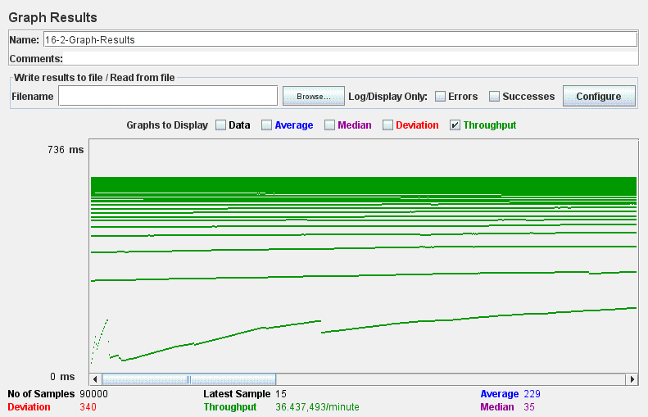

**16.3 – Remove a chirp that he or she thinks is inappropriate being an administrator.**

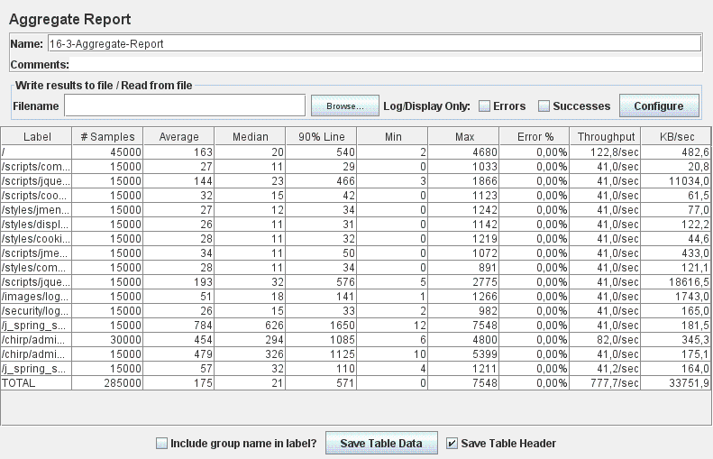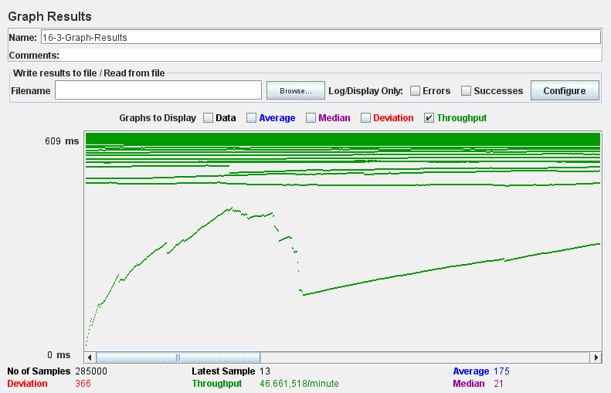

**16.4 – List the comments that contain taboo words being an administrator.**

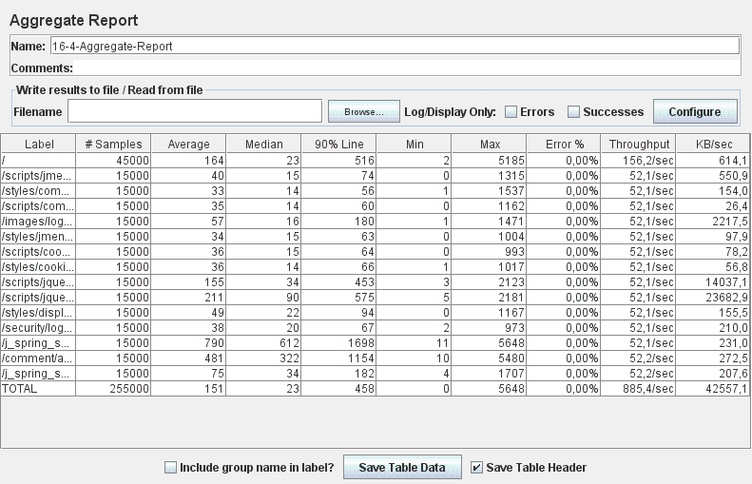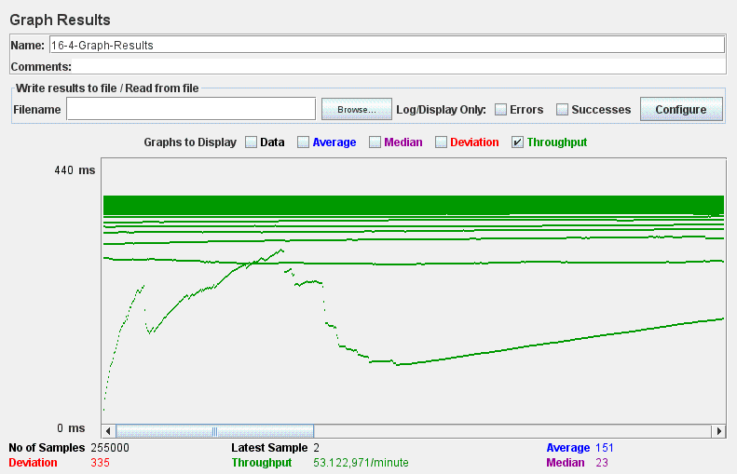

**16.5 – Remove a comment that he or she thinks is inappropriate being an administrator.**

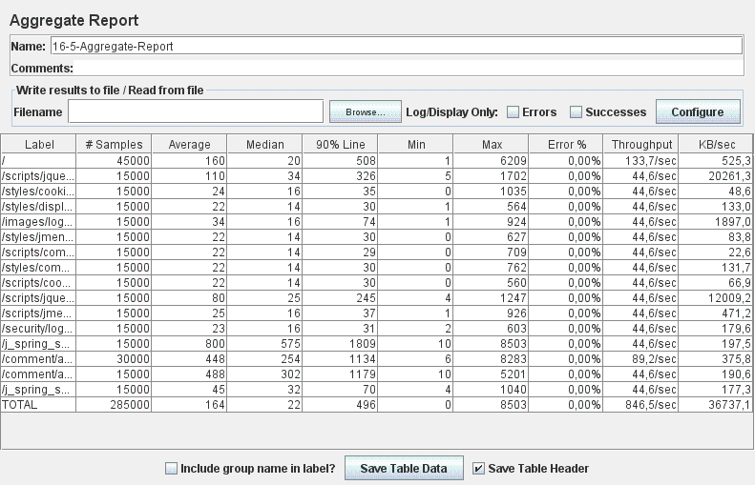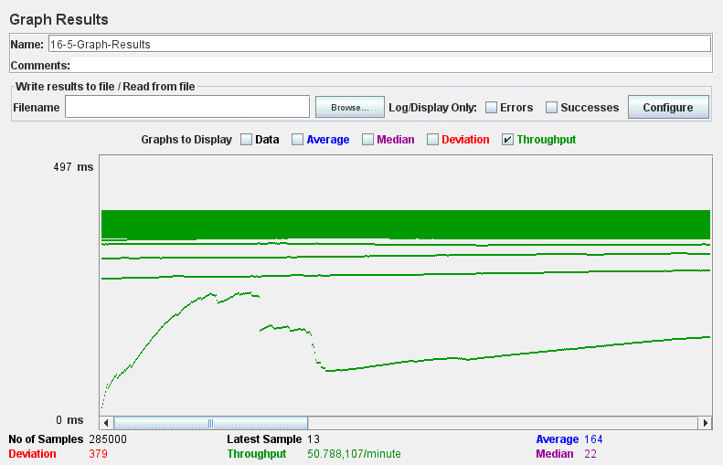

**16.6 – Display a dashboard being an administrator.**

